LAB DAY 1: INCEPTION OF OPEN-SOURCE EDA, OPENLANE AND SKY130 PDK

The observation of day 1:

* To setup the directory for running synthesis
* Run docker and flow.tcl file in interactive mode to open the bash interface
* To Perform synthesis of the design picorv32a and analyze the flop ratio

Set up the directory to the OpenLANE flow

cd Desktop/work/tools/openlane_working_dir/openlane

Run docker to open bash

$ docker

Start OpenLANE in interactive mode

./flow.tcl -interactive

Load the required openlane packages with the version 0.9

%package require openlane 0.9

Create the design picorv32a for synthesis

prep -design picorv32a

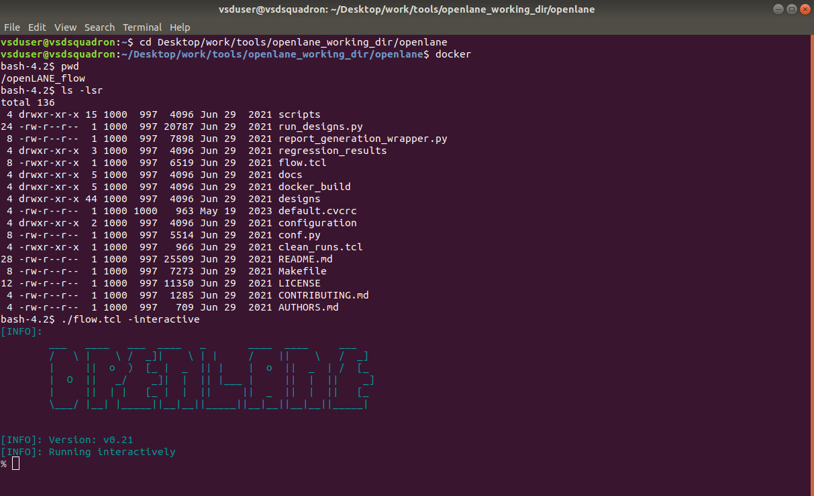

Run the synthesis

run_synthesis

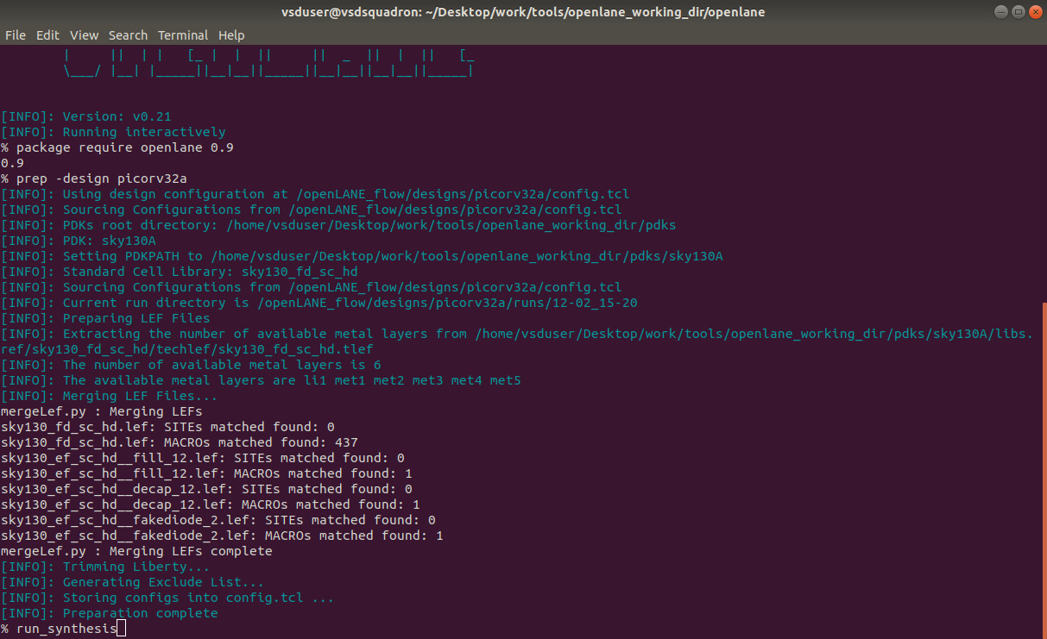

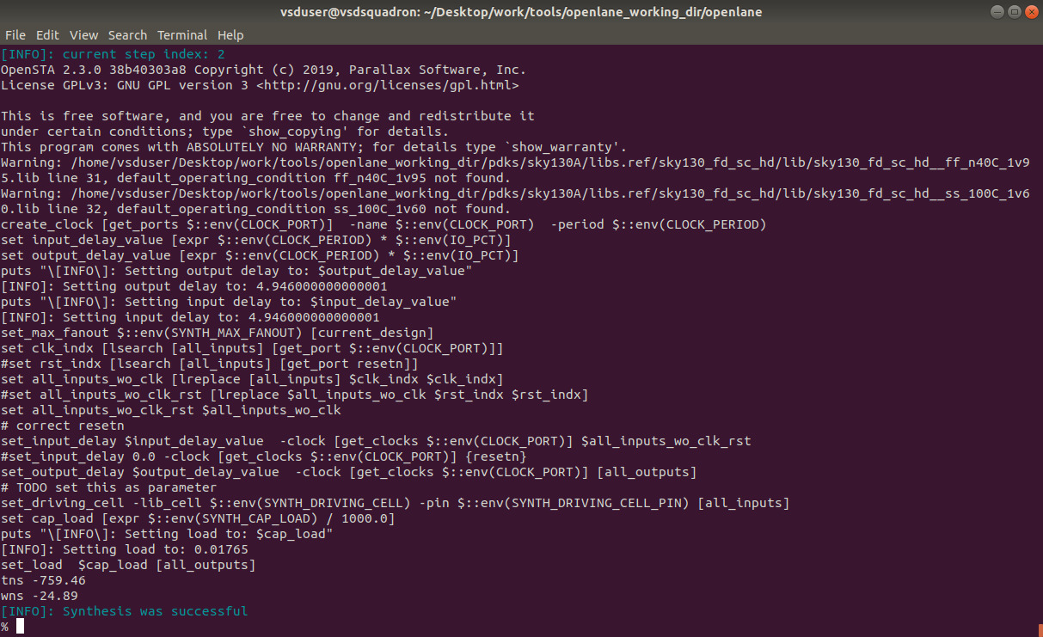

After completion of the synthesis, navigate to the yosys file to calculate the flop ration. The path of the yosys file is given below

cd Desktop/work/tools/openlane_working_dir/openlane/designs/picorv32a/runs/(date)/reports/synthesis: less 1-yosys_4.stat.rpt

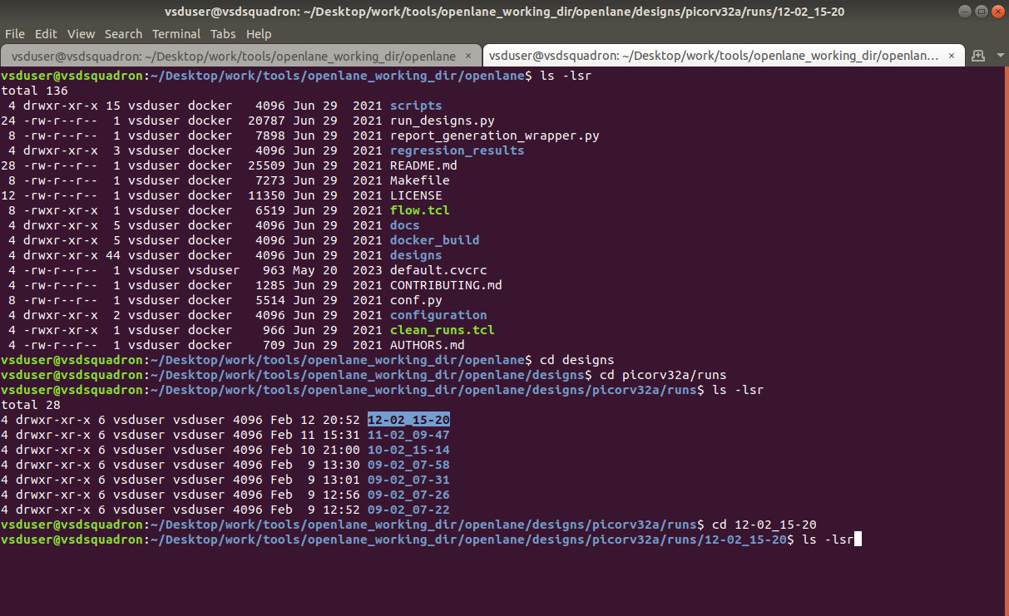

The count of flip-flops is given by 'sky130_fd_sc_hd__dfxtp_2'

Count of flip-flops: 1613

Number of cells: 14876

Flop Ratio = (Number of Flip-Flops) / (Total Number of Cells)

Flop ratio = 1613/14876 = 0.1084 [10.84%]

